Review & Creating GitHub Issues
Working with your Trio/Buddy:
- Discuss: If you could instantly become an expert in one subject, what would it be?
- Reflection: What's something you admire about each of your group members, and how has it impacted your work together?
- Explore: Ask one another how your GitHub issues can be more clear. Is there missing context? Is the “ask” obvious?

Open Source Activity: this milestone you were supposed to become a contributor on an open source project. How did that process go? Did you complete the task? What did you learn? Did you see any open issues that you are interested in contributing to? During your project share, you will also show how far you have come in the process of becoming a contributor and what you learned in doing so. You will have 1 additional minute to present this.

GitHub Issues Activity: You should have been exposed to creating GitHub issues by now. If you need a refresher, watch this video on creating GitHub issues. You need to go back to your past milestone’s projects and add three different issues. The purpose of this exercise is to get you thinking about your projects in a collaborative way. Create issues that call out bugs, new features, or prospective optimization, so that your future self and your cohort-mate * hint hint * can resolve the issue. You want to be as detailed as you can about the existing state of the issue you are reporting (a screenshot or GIF), as well as where to find the issue (link to specific files or lines of code), how to recreate it, the existing behavior, and desired behavior. Be prepared to also share your three issues during today’s project share. You will have 2 additional minutes to present this.

Discuss: what is happening in this picture? Make connections to what you’ve learned so far in the program
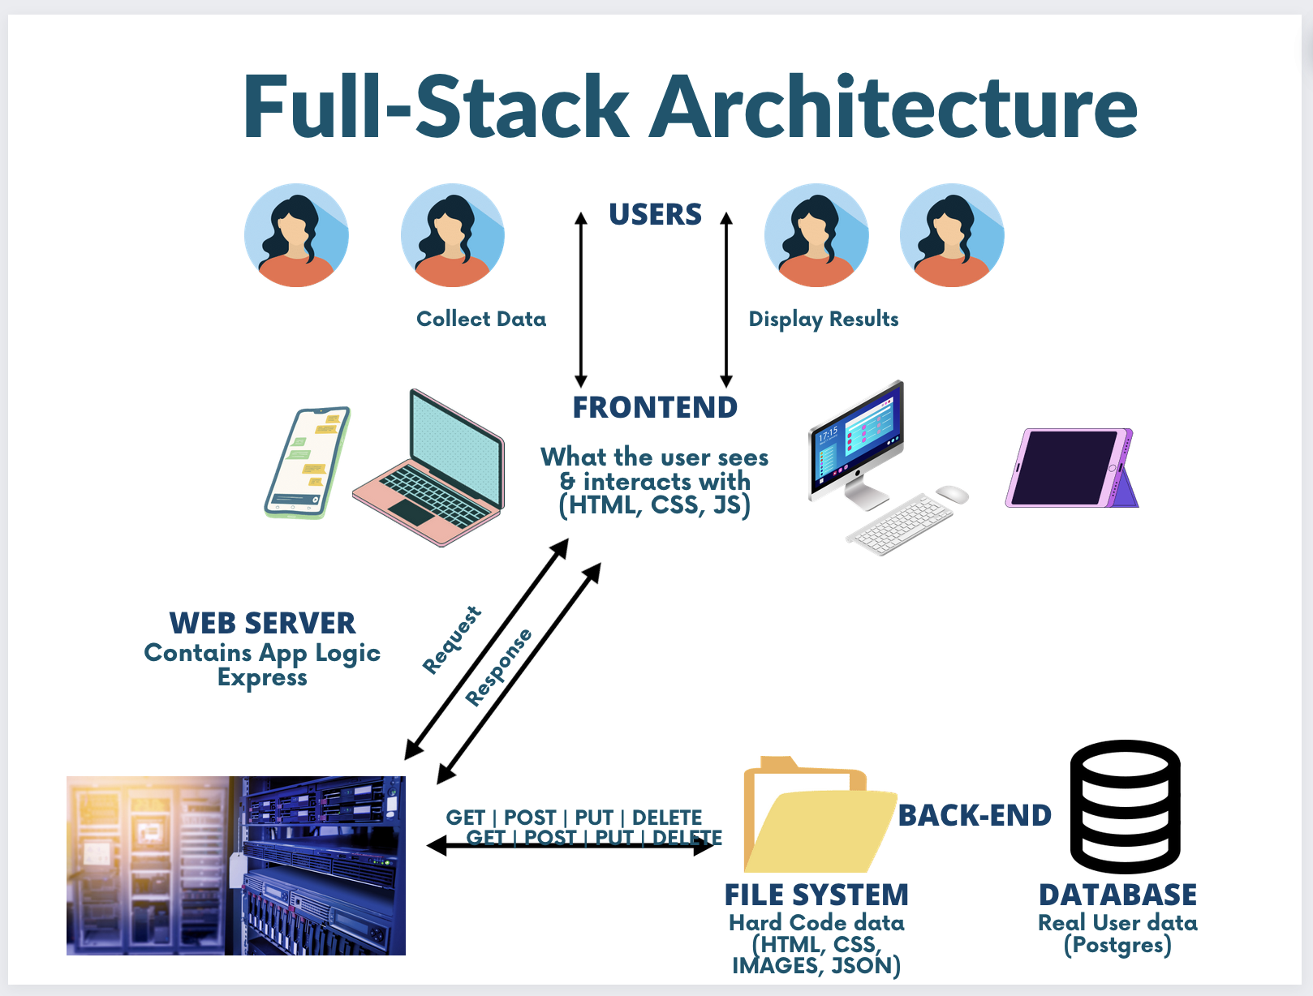

Async, Callbacks, Promises
- What is a callback function?
- Why do we use callbacks?
- How many things can be returned from a callback?
- How do I get data out of a callback?
- Define a promise in your own words.

.env & config files
- What is a .env?
- What is a config file?
- How do you use .env and config files together

Data Modeling: Single and Multiple tables
- What is a Table?
- What is an Entity?
- What is an Attribute?
- What are the Data types in a DB?
- What is a Schema?
- Give me an example of the 3 types of data relationships:
  - One-to-one
  - One-to-many
  - Many-to-many.
- What are primary keys?
- What are foreign keys?
- What is database normalization?

SQL
- What are joins?
- What are junction tables?
- What is a query?
- What are the keywords to find, remove, and change data?

CSS topics
- Navigation tabs
- Navigation bars
- Cards

